

CSE471: System Analysis and Design Project Title: Pokémon Battle Simulator
SDLC Model Description & UML Diagram

CSE471 Fall ’25 Lab Section: 09
Group: 01
ID | Name
22301533 | Safkatur Rahman
22101300 | Nur Abir
22101384 | Mohammad Mehedi Hasan
22301164 | Abrar Ahmed

1.1 SDLC Model Description

We divided our project into three modules, each of which will be developed over three weeks. With four team members working simultaneously, we will follow an Incremental Model with Parallel Development.

Each module served as a separate increment. In Week 1, we will develop the user management and authentication system. In Week 2, we will work on the team-building system, and in Week 3, we will implement the battle system and leaderboards. Each stage will build on the previous one, demonstrating a clear incremental structure.

Within each module, all four of us will work in parallel on different but related tasks, such as registration, profile management, notifications, and admin features. This approach will enable faster, more efficient development. We will also maintain functional ownership, with each member responsible for related features across all modules to ensure consistency.

Overall, our approach will clearly reflect the Incremental Model with Parallel Development. It will enable us to deliver a complete system efficiently and complete the project within three weeks.

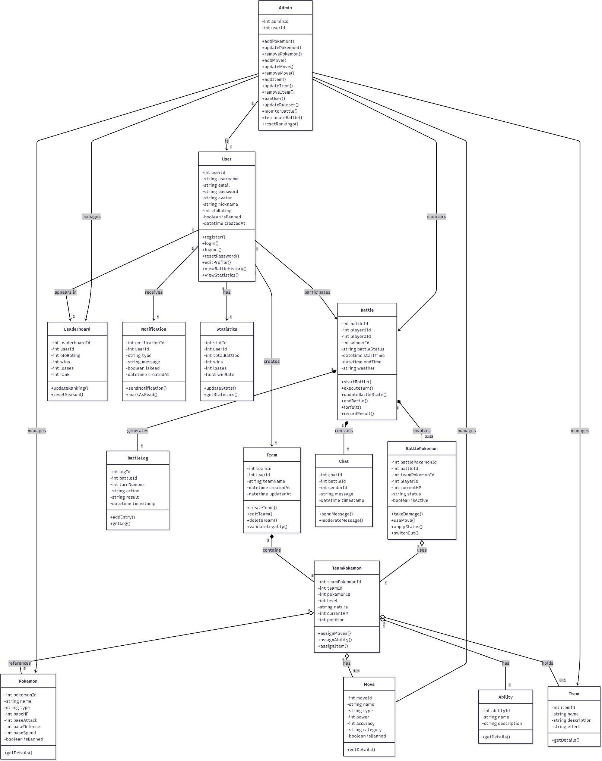
2.1 Class Diagram

Link to Better Viewing Experience

